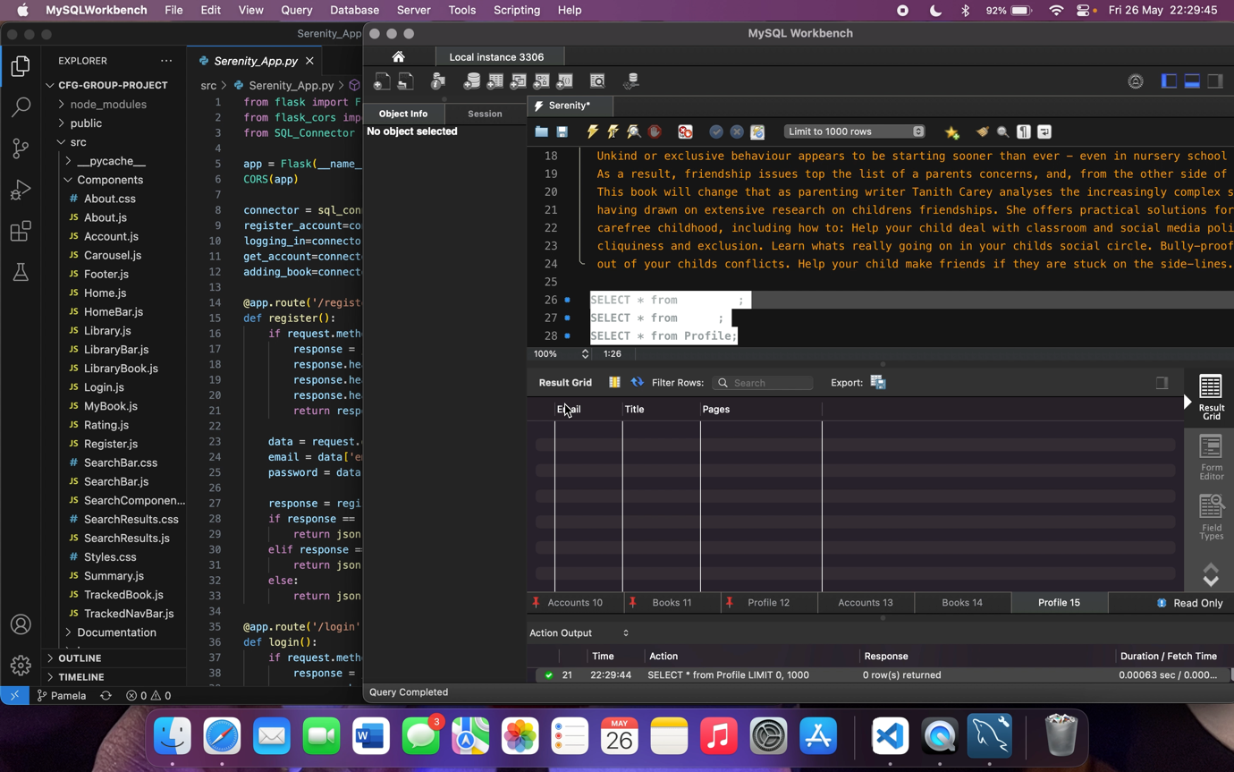The screen recording includes audio and shows the login and registration process successfully working under certain conditions (on my laptop/IP address) and also updating the SQL database.

It also shows how the ‘add to list’ button partially works. It successfully updates the SQL database with the book name and number of pages (directly from the API website) but is unsuccessful in adding the logged-in user’s email with it.